Name

Tornadoes
Learn facts about tornadoes.
Read the passage and answer the questions.
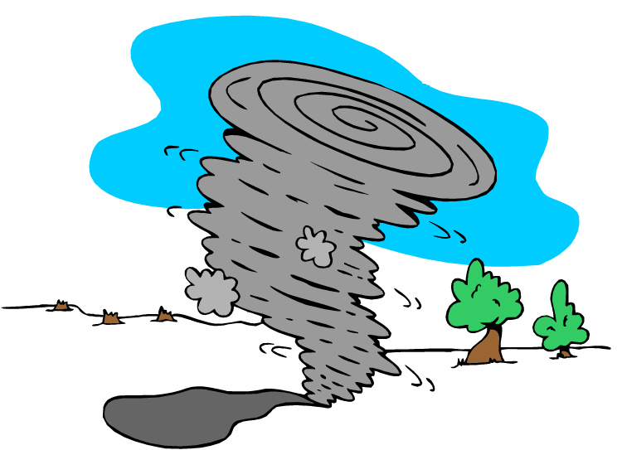
A tornado is a violent rotating column of air coming from the clouds in a thunderstorm down to the ground. The strongest tornadoes can be very destructive, with winds up to 300 miles per hour. Most tornadoes form from thunderstorms. When warm, moist air from the Gulf of Mexico meets cold, dry air from Canada, the atmosphere becomes unstable. The wind changes direction and increases in speed. This causes a horizontal spinning in the lower atmosphere, which creates a two to five mile wide area of rotation out of which violent tornadoes can form. A funnel cloud is basically a tornado that is not touching the ground. Once a funnel cloud touches down it becomes a tornado. Tornadoes can destroy large buildings, rip trees from the ground, and throw cars hundreds of yards. The path of damage can be as large as a mile wide and 50 miles long. Weather stations warn people when tornadoes are in the area so that they can find shelter.
Copyright © 2011 Savetz Publishing Inc. • www.InstantWorksheets.net

- How does a tornado form?

- How fast can the winds in a tornado be?

- What two kinds of air meet to cause these storms?

- What is the difference between a funnel cloud and a tornado?

- How big can the path of destruction be?
Copyright © 2011 Savetz Publishing Inc. • www.InstantWorksheets.net

